Project Design Phase-II
Technology Stack (Architecture & Stack)

Date | 27 FEB 2026
Team ID | LTVIP2026TMIDS41352
Project Name | ShopEZ:One-Stop Shop for Online Purchases
Maximum Marks | 4 Marks

Technical Architecture:
ShopEZ follows a 3-Tier MERN Architecture consisting of:
- Presentation Layer (Frontend)
- Application Layer (Backend APIs)
- Data Layer (Database)

Reference: https://developer.ibm.com/patterns/ai-powered-backend-system-for-order-processing-during-pandemics/
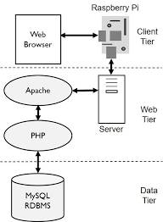
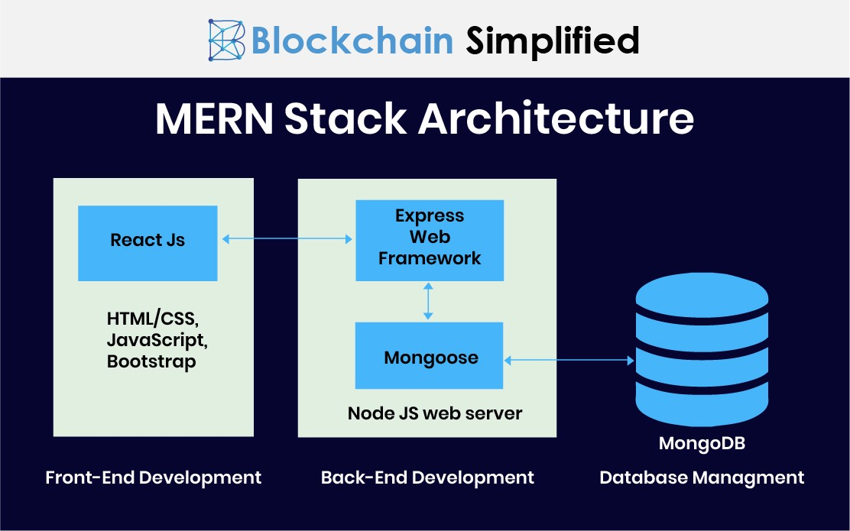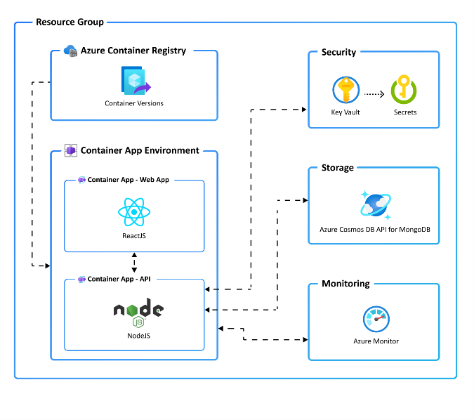

Table-1 : Components & Technologies:
S.No | Component | Description | Technology
1 | User Interface | Web-based interface for customers, sellers, and admin | HTML, CSS, Bootstrap, React JS
2 | Application Logic-1 | User authentication & authorization | Node.js, Express.js, JWT
3 | Application Logic-2 | Product & Cart management | Node.js, Express.js
4 | Application Logic-3 | Order processing & seller dashboard | Node.js, Express.js
5 | Database | Stores users, products, orders, cart data | MongoDB (NoSQL)
6 | Cloud Database | Managed database service | MongoDB Atlas
7 | File Storage | Product images storage | Cloudinary / Local File System
8 | External API-1 | Payment Integration | Razorpay / Stripe API
9 | External API-2 | Email Notification Service | Nodemailer / SendGrid
10 | Machine Learning Model | (Future Scope) Product Recommendation | Basic Recommendation Logic / ML Model
11 | Infrastructure | Application Deployment | Render / Vercel / AWS / Local Server

Table-2: Application Characteristics:
S.No | Characteristics | Description | Technology Used
1 | Open-Source Frameworks | Frameworks used for development | React JS, Node.js, Express.js, MongoDB
2 | Security Implementations | Secure authentication and data protection | JWT, Bcrypt Password Hashing, HTTPS, Role-Based Access
3 | Scalable Architecture | 3-Tier Architecture supporting horizontal scaling | MERN Stack, Cloud Hosting
4 | Availability | 24/7 availability via cloud deployment | MongoDB Atlas, Cloud Hosting
5 | Performance | Optimized API calls and fast page rendering | React Virtual DOM, Indexed Queries, Caching
6 | Maintainability | Modular folder structure for frontend & backend | MVC Architecture Pattern
7 | Reliability | Proper error handling & validation | Express Middleware Validation

References:
• C4 Model for Software Architecture.
Available at: https://c4model.com/
Accessed for understanding system context, container, and component-level architectural diagrams.
• IBM Developer – Online Order Processing System During Pandemic.
Available at: https://developer.ibm.com/patterns/online-order-processing-system-during-pandemic/
Referenced for architectural pattern inspiration and scalable backend design.
• IBM Cloud Architecture Center.
Available at: https://www.ibm.com/cloud/architecture
Used for understanding cloud-native application deployment models.
• AWS Architecture Center.
Available at: https://aws.amazon.com/architecture
Referenced for best practices in scalable and distributed system design.
• Medium – How to Draw Useful Technical Architecture Diagrams.
Available at: https://medium.com/the-internal-startup/how-to-draw-useful-technical-architecture-diagrams-2d20c9fda90d
Used as guidance for structuring architecture diagrams.
• MongoDB Official Documentation.
Available at: https://www.mongodb.com/docs/
Referenced for database schema design and configuration.
• React.js Official Documentation.
Available at: https://react.dev/
Used for frontend component architecture and state management understanding.
• Node.js Official Documentation.
Available at: https://nodejs.org/en/docs/
Referenced for backend server setup and API handling.
• Express.js Documentation.
Available at: https://expressjs.com/
Used for REST API development and middleware implementation.
• JSON Web Token (JWT) Documentation.
Available at: https://jwt.io/
Referenced for authentication implementation.

